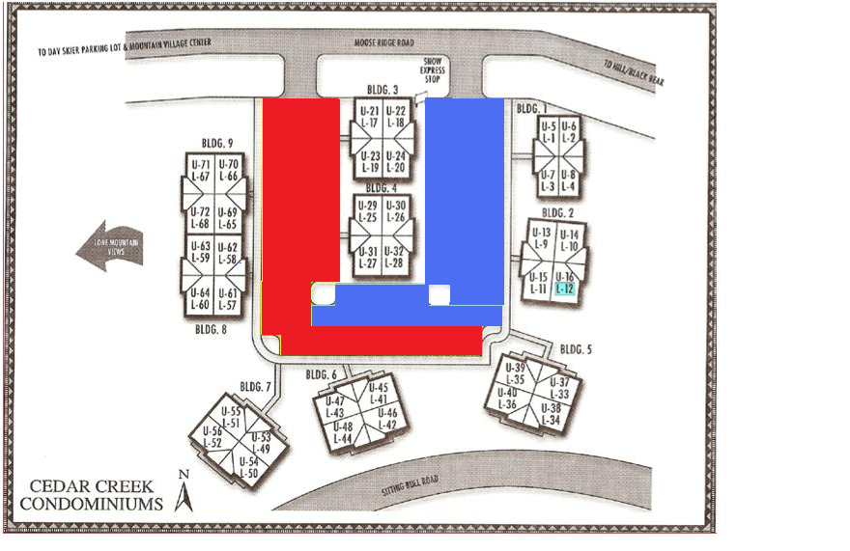
Cedar Creek 2025/2026 Plow Schedule
UPPER LOT
December 16th, 2025
January 6th, 2026
January 20th, 2026
February 3rd, 2026
February 17th, 2026
March 3rd, 2026
LOWER LOT
December 17th, 2025
January 7th, 2026
January 21st, 2026
February 4th, 2026
February 18th, 2026
March 4th, 2026

March 24th, 2026 March 25th, 2026
All vehicles must be removed by 8:30am from the scheduled lot. Any vehicle left in the lot after 8:30am may be wheel locked without notice and a $100 fine (cash or check) must be paid to “CCUA Parking Fine On (fill in the date)” at American Bank of Montana in the Meadow Village before the wheel lock is removed. During the plow hours, cars may be parked, without blocking entrances to parking lots, on the north side (opposite side) of Moose Ridge Road or on Sitting Bull Road. Vehicles may be moved back into the lot after 2:00 pm on the same day. SCHEDULE QUESTION: email board@cedarcreekowners.com. PROBLEM ON PLOW DAY: Shawn, Text Only: 406-589-4931.

